Organizational Culture In-depth

Customer Service Culture: The Case of Nordstrom
Nordstrom Inc. is a Seattle-based department store rivaling the likes of Saks Fifth Avenue, Neiman Marcus, and Bloomingdale’s. Nordstrom is a Hall of Fame member of Fortune Magazine’s 100 Best Companies to Work for list. Nordstrom is known for its quality apparel, upscale environment, and generous employee rewards. The retailer is most famous for is its delivery of customer service above and beyond the norms of the retail industry. Stories about Nordstrom's service abound. For example, according to one story the company confirms, in 1975 Nordstrom moved into a new location that had formerly been a tire store. A customer brought a set of tires into the store to return them. Without a word about the mix-up, the tires were accepted and the customer was fully refunded the purchase price. In a different story, a customer tried on several pairs of shoes but failed to find the right combination of size and color. As she was about to leave, the clerk called other Nordstrom stores, but could only locate the right pair at Macy’s, a nearby competitor. The clerk had Macy’s ship the shoes to the customer’s home at Nordstrom’s expense. In a third story, a customer describes wandering into a Portland, Oregon Nordstrom looking for an Armani tuxedo for his daughter’s wedding. The sales associate took his measurements just in case one was found. The next day, the customer got a phone call, informing him that the tux was available. When pressed, she revealed that using her connections she found one in New York, had it put on a truck destined to Chicago, and dispatched someone to meet the truck in Chicago at a rest stop. The next day she shipped the tux to the customer’s address, and the customer found that the tux had already been altered for his measurements and was ready to wear. What is even more impressive about this story is that Nordstrom does not sell Armani tuxedos.
How does Nordstrom persist in creating these stories? If you guessed that they have a large number of rules and regulations designed to emphasize quality in customer service, you’d be wrong. In fact, the company gives employees a 5½- inch by 7½-inch card as the employee handbook. On one side of the card, the company welcomes employees to Nordstrom, states that their number one goal is to provide outstanding customer service, and for this they have only one rule. On the other side of the card, the single rule is stated: Use good judgment in all situations. By leaving it in the hands of Nordstrom associates, the company seems to have managed to empower employees who deliver customer service heroics every day (Chatman & Eunyoung, 2003; McCarthy & Spector, 2005; Pfeffer, 2005).
Just like individuals, you can think of organizations as having their own personalities, more typically known as organizational cultures. The opening case illustrates that Nordstrom is a retailer with the foremost value of making customers happy. At Nordstrom, when a customer is unhappy, employees are expected to identify what would make the person satisfied, and then act on it, without necessarily checking with a superior or consulting a lengthy policy book. If they do not, they receive peer pressure and may be made to feel that they let the company down. In other words, this organization seems to have successfully created a service culture. Understanding how culture is created, communicated, and changed will help you be more effective in your organizational life. But first, let’s define organizational culture.

What Is Organizational Culture?
Organizational culture refers to a system of shared assumptions, values, and beliefs that show employees what is appropriate and inappropriate behavior (Chatman & Eunyoung, 2003; Kerr & Slocum, 2005). These values have a strong influence on employee behavior as well as organizational performance. In fact, the term organizational culture was made popular in the 1980s when Peters and Waterman’s best-selling book In Search of Excellence made the argument that company success could be attributed to an organizational culture that was decisive, customer oriented, empowering, and people oriented. Since then, organizational culture has become the subject of numerous research studies, books, and articles. However, organizational culture is still a relatively new concept. In contrast to a topic such as leadership, which has a history spanning several centuries, organizational culture is a young but fast-growing area within organizational behavior.
Culture is by and large invisible to individuals. Even though it affects all employee behaviors, thinking, and behavioral patterns, individuals tend to become more aware of their organization’s culture when they have the opportunity to compare it to other organizations. If you have worked in multiple organizations, you can attest to this. Maybe the first organization you worked was a place where employees dressed formally. It was completely inappropriate to question your boss in a meeting; such behaviors would only be acceptable in private. It was important to check your email at night as well as during weekends or else you would face questions on Monday about where you were and whether you were sick. Contrast this company to a second organization where employees dress more casually. You are encouraged to raise issues and question your boss or peers, even in front of clients. What is more important is not to maintain impressions but to arrive at the best solution to any problem. It is widely known that family life is very important, so it is acceptable to leave work a bit early to go to a family event. Additionally, you are not expected to do work at night or over the weekends unless there is a deadline. These two hypothetical organizations illustrate that organizations have different cultures, and culture dictates what is right and what is acceptable behavior as well as what is wrong and unacceptable.

Why Does Organizational Culture Matter?
An organization’s culture may be one of its strongest assets, as well as its biggest liability. In fact, it has been argued that organizations that have a rare and hard-to-imitate organizational culture benefit from it as a competitive advantage (Barney, 1986). In a survey conducted by the management consulting firm Bain & Company in 2007, worldwide business leaders identified corporate culture as important as corporate strategy for business success. ("Why culture can mean life or death," 2007). This comes as no surprise to many leaders of successful businesses, who are quick to attribute their company’s success to their organization’s culture.
Culture, or shared values within the organization, may be related to increased performance. Researchers found a relationship between organizational cultures and company performance, with respect to success indicators such as revenues, sales volume, market share, and stock prices (Kotter & Heskett, 1992; Marcoulides & Heck, 1993). At the same time, it is important to have a culture that fits with the demands of the company’s environment. To the extent shared values are proper for the company in question, company performance may benefit from culture (Arogyaswamy & Byles, 1987). For example, if a company is in the high-tech industry, having a culture that encourages innovatiion and adaptability will support its performance. However, if a company in the same industry has a culture characterized by stability, a high respect for tradition, and a strong preference for upholding rules and procedures, the company may suffer as a result of its culture. In other words, just as having the “right” culture may be a competitive advantage for an organization, having the “wrong” culture may lead to performance difficulties, may be responsible for organizational failure, and may act as a barrier preventing the company from changing and taking risks.
In addition to having implications for organizational performance, organizational culture is an effective control mechanism for dictating employee behavior. Culture is in fact a more powerful way of controlling and managing employee behaviors than organizational rules and regulations. When problems are unique, rules tend to be less helpful. Instead, creating a culture of customer service achieves the same result by encouraging employees to think like customers, knowing that the company priorities in this case are clear: Keeping the customer happy is preferable to other concerns such as saving the cost of a refund.

Levels of Organizational Culture
Organizational culture consists of some aspects that are relatively more visible, as well as aspects that may lie below one’s conscious awareness. Organizational culture can be thought of as consisting of three interrelated levels (Schein, 1992).
At the deepest level, below our awareness lie basic assumptions. Assumptions are taken for granted, and they reflect beliefs about human nature and reality. At the second level, values exist. Values are shared principles, standards, and goals. Finally, at the surface we have artifacts, or visible, tangible aspects of organizational culture. For example, in an organization one of the basic assumptions employees and managers share might be that happy employees benefit their organizations. This assumption could translate into values such as social equality, high quality relationships, and having fun. The artifacts reflecting such values might be an executive “open door” policy, an office layout that includes open spaces and gathering areas equipped with pool tables, and frequent company picnics in the workplace. For example, Alcoa Inc. designed their headquarters to reflect the values of making people more visible and accessible, and to promote collaboration (Stegmeier, 2008). In other words, understanding the organization’s culture may start from observing its artifacts: the physical environment, employee interactions, company policies, reward systems, and other observable characteristics. When you are interviewing for a position, observing the physical environment, how people dress, where they relax, and how they talk to others is definitely a good start to understanding the company’s culture. However, simply looking at these tangible aspects is unlikely to give a full picture of the organization. An important chunk of what makes up culture exists below one’s degree of awareness. The values and, at a deeper level, the assumptions that shape the organization’s culture can be uncovered by observing how employees interact and the choices they make, as well as by inquiring about their beliefs and perceptions regarding what is right and appropriate behavior.
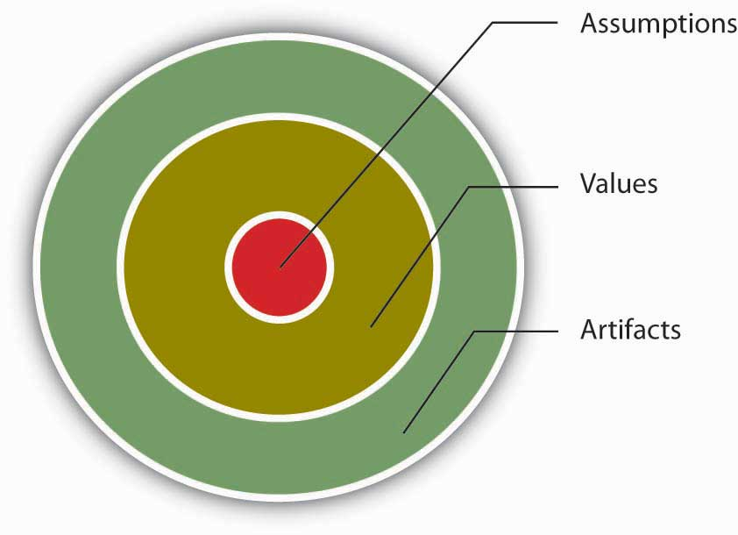
Organizational culture consists of three levels.
Source: Adapted from Schein, E. H. (1992). Organizational culture and leadership. San Francisco: Jossey-Bass.

Key Takeaway
Organizational culture is a system of shared assumptions, values, and beliefs that help individuals within an organization understand which behaviors are and are not appropriate within an organization. Cultures can be a source of competitive advantage for organizations. Strong organizational cultures can be an organizing as well as a controlling mechanism for organizations. And finally, organizational culture consists of three levels: assumptions, which are below the surface, values, and artifacts.

Characteristics of Organizational Culture

Dimensions of Culture
Which values characterize an organization’s culture? Even though culture may not be immediately observable, identifying a set of values that might be used to describe an organization’s culture helps us identify, measure, and manage culture more effectively. For this purpose, several researchers have proposed various culture typologies. One typology that has received a lot of research attention is the organizational culture profile (OCP), in which culture is represented by seven distinct values (Chatman & Kerr, 1991; O'Reilly, Chatman, & Caldwell, 1991). We will describe the OCP as well as two additional dimensions of organizational culture that are not represented in that framework but are important dimensions to consider: service culture and safety culture.

Innovative Cultures
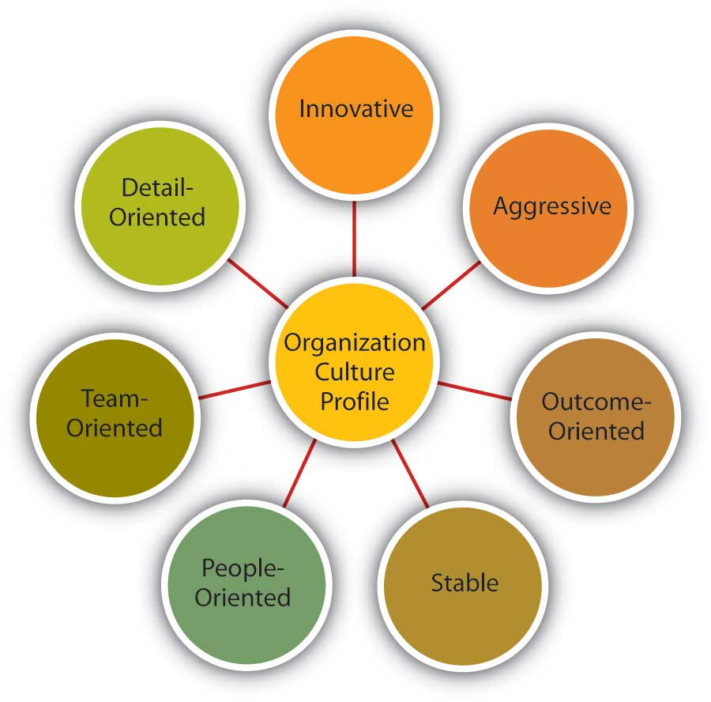
Dimensions of Organizational Culture Profile
Source: Adapted from information in O’Reilly, C. A., III, Chatman, J. A., & Caldwell, D. F. (1991). People and organizational culture: A profile comparison approach to assessing person-organization fit. Academy of Management Journal, 34, 487–516.
According to the OCP framework, companies that have innovative cultures are flexible and adaptable, and experiment with new ideas. These companies are characterized by a flat hierarchy in which titles and other status distinctions tend to be downplayed. For example, W. L. Gore & Associates Inc. is a company with innovative products such as GORE-TEX® (the breathable fabric that is windproof and waterproof), Glide dental floss, and Elixir guitar strings, earning the company the distinction of being elected as the most innovative company in the United States by Fast Company magazine in 2004. W. L. Gore consistently manages to innovate and capture the majority of market share in a wide variety of industries, in large part due to its unique culture. In this company, employees do not have bosses in the traditional sense, and risk taking is encouraged by celebrating failures as well as successes (Deutschman, 2004). Companies such as W. L. Gore, Genentech Inc., and Google also encourage their employees to take risks by allowing engineers to devote 20 percent of their time to projects of their own choosing.

Aggressive Cultures
Companies with aggressive cultures value competitiveness and outperforming competitors. By emphasizing this attribute, they may fall short in the area of corporate social responsibility. For example, Microsoft Corporation is often identified as a company with an aggressive culture. The company has faced a number of antitrust lawsuits and disputes with competitors over the years. In aggressive companies, people may use language such as “We will kill our competition.” In the past, Microsoft executives often made statements such as “We are going to cut off Netscape’s air supply.…Everything they are selling, we are going to give away.” Its aggressive culture is cited as a reason for getting into new legal troubles before old ones are resolved (Greene, Reinhardt, & Lowry, 2004; Schlender, 1998). Recently, Microsoft founder Bill Gates established the Bill & Melinda Gates foundation and is planning to devote his time to reducing poverty around the world (Schlender, 2007). It will be interesting to see whether he will bring the same competitive approach to the world of philanthropy.

Outcome-Oriented Cultures
The OCP framework describes outcome-oriented cultures as those that emphasize achievement, results, and action as important values. A good example of an outcome-oriented culture may be Best Buy Co. Inc. Having a culture emphasizing sales performance, Best Buy tallies revenues and other relevant figures daily by department. Employees are trained and mentored to sell company products effectively, and they learn how much money their department made every day (Copeland, 2004). In 2005, the company implemented a results oriented work environment (ROWE) program that allows employees to work anywhere and anytime; they are evaluated based on results and fulfillment of clearly outlined objectives. (Thompson, 2005). Outcome-oriented cultures hold employees as well as managers accountable for success and utilize systems that reward employee and group output. In these companies, it is more common to see rewards tied to performance indicators as opposed to seniority or loyalty. Research indicates that organizations that have a performance-oriented culture tend to outperform companies that are lacking such a culture (Nohria, Joyce, & Roberson, 2003). At the same time, some outcome-oriented companies may have such a high drive for outcomes and measurable performance objectives that they may suffer negative consequences. Companies overrewarding employee performance such as Enron Corporation and WorldCom experienced well-publicized business and ethical failures. When performance pressures lead to a culture where unethical behaviors become the norm, individuals see their peers as rivals and short-term results are rewarded; the resulting unhealthy work environment serves as a liability (Probst & Raisch, 2005).

Stable Cultures
Stable cultures are predictable, rule oriented, and bureaucratic. These organizations aim to coordinate and align individual effort for greatest levels of efficiency. When the environment is stable and certain, these cultures may help the organization be effective by providing stable and constant levels of output (Westrum, 2004). These cultures prevent quick action, and as a result may be a misfit to a changing and dynamic environment. Public sector institutions may be viewed as stable cultures. In the private sector, Kraft Foods Inc. is an example of a company with centralized decision making and rule orientation that suffered as a result of the culture-environment mismatch (Thompson, 2006). Its bureaucratic culture is blamed for killing good ideas in early stages and preventing the company from innovating. When the company started a change program to increase the agility of its culture, one of their first actions was to fight bureaucracy with more bureaucracy: They created the new position of VP of business process simplification, which was later eliminated (Boyle, 2004; Thompson, 2005).

People-Oriented Cultures
People-oriented cultures value fairness, supportiveness, and respect for individual rights. These organizations truly live the mantra that “people are their greatest asset.” In addition to having fair procedures and management styles, these companies create an atmosphere where work is fun and employees do not feel required to choose between work and other aspects of their lives. In these organizations, there is a greater emphasis on and expectation of treating people with respect and dignity (Erdogan, Liden, & Kraimer, 2006). One study of new employees in accounting companies found that employees, on average, stayed 14 months longer in companies with people-oriented cultures (Sheridan, 1992). Starbucks Corporation is an example of a people-oriented culture. The company pays employees above minimum wage, offers health care and tuition reimbursement benefits to its part-time as well as full-time employees, and has creative perks such as weekly free coffee for all associates. As a result of these policies, the company benefits from a turnover rate lower than the industry average (Weber, 2005).

Team-Oriented Cultures
Companies with team-oriented cultures are collaborative and emphasize cooperation among employees. For example, Southwest Airlines Company facilitates a team-oriented culture by cross-training its employees so that they are capable of helping each other when needed. The company also places emphasis on training intact work teams (Bolino & Turnley, 2003). Employees participate in twice daily meetings named “morning overview meetings” (MOM) and daily afternoon discussions (DAD) where they collaborate to understand sources of problems and determine future courses of action. In Southwest’s selection system, applicants who are not viewed as team players are not hired as employees (Miles & Mangold, 2005). In team-oriented organizations, members tend to have more positive relationships with their coworkers and particularly with their managers (Erdogan, Liden, & Kraimer, 2006).

Detail-Oriented Cultures
Organizations with detail-oriented cultures are characterized in the OCP framework as emphasizing precision and paying attention to details. Such a culture gives a competitive advantage to companies in the hospitality industry by helping them differentiate themselves from others. For example, Four Seasons Hotels Ltd. and the Ritz-Carlton Company LLC are among hotels who keep records of all customer requests, such as which newspaper the guest prefers or what type of pillow the customer uses. This information is put into a computer system and used to provide better service to returning customers. Any requests hotel employees receive, as well as overhear, might be entered into the database to serve customers better. Recent guests to Four Seasons Paris who were celebrating their 21st anniversary were greeted with a bouquet of 21 roses on their bed. Such clear attention to detail is an effective way of impressing customers and ensuring repeat visits. McDonald’s Corporation is another company that specifies in detail how employees should perform their jobs by including photos of exactly how French fries and hamburgers should look when prepared properly (Fitch, 2004; Ford & Heaton, 2001; Kolenikov-Jessop, 2005).

Service Culture
Service culture is not one of the dimensions of OCP, but given the importance of the retail industry in the overall economy, having a service culture can make or break an organization. Some of the organizations we have illustrated in this section, such as Nordstrom, Southwest Airlines, Ritz-Carlton, and Four Seasons are also famous for their service culture. In these organizations, employees are trained to serve the customer well, and cross-training is the norm. Employees are empowered to resolve customer problems in ways they see fit. Because employees with direct customer contact are in the best position to resolve any issues, employee empowerment is truly valued in these companies. For example, Umpqua Bank, operating in the northwestern United States, is known for its service culture. All employees are trained in all tasks to enable any employee to help customers when needed. Branch employees may come up with unique ways in which they serve customers better, such as opening their lobby for community events or keeping bowls full of water for customers’ pets. The branches feature coffee for customers, Internet kiosks, and withdrawn funds are given on a tray along with a piece of chocolate. They also reward employee service performance through bonuses and incentives (Conley, 2005; Kuehner-Herbert, 2003).
What differentiates companies with service culture from those without such a culture may be the desire to solve customer-related problems proactively. In other words, in these cultures employees are engaged in their jobs and personally invested in improving customer experience such that they identify issues and come up with solutions without necessarily being told what to do. For example, a British Airways baggage handler noticed that first-class passengers were waiting a long time for their baggage, whereas stand-by passengers often received their luggage first. Noticing this tendency, a baggage handler notified his superiors about this problem, along with the suggestion to load first-class passenger luggage last (Ford & Heaton, 2001). This solution was successful in cutting down the wait time by half. Such proactive behavior on the part of employees who share company values is likely to emerge frequently in companies with a service culture.

Safety Culture
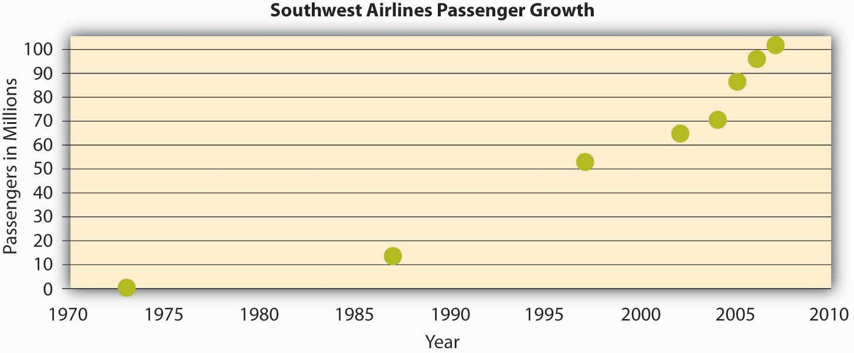
The growth in the number of passengers flying with Southwest Airlines from 1973 until 2007. In 2007, Southwest surpassed American Airlines as the most flown domestic airline. While price has played a role in this, their emphasis on service has been a key piece of their culture and competitive advantage.
Source: Adapted from http://upload.wikimedia.org/wikipedia/commons/6/69/Southwest-airlines-passengers.jpg.
Some jobs are safety sensitive. For example, logger, aircraft pilot, fishing worker, steel worker, and roofer are among the top 10 most dangerous jobs in the United States (Christie, 2005). In organizations where safety-sensitive jobs are performed, creating and maintaining a safety culture provides a competitive advantage, because the organization can reduce accidents, maintain high levels of morale and employee retention, and increase profitability by cutting workers’ compensation insurance costs. Some companies suffer severe consequences when they are unable to develop such a culture. For example, British Petroleum experienced an explosion in their Texas City, Texas, refinery in 2005, which led to the death of 15 workers while injuring 170. In December 2007, the company announced that it had already depleted the $1.6-billion fund to be used in claims for this explosion (Tennissen, 2007). A safety review panel concluded that the development of a safety culture was essential to avoid such occurrences in the future (Hofmann, 2007). In companies that have a safety culture, there is a strong commitment to safety starting at management level and trickling down to lower levels. M. B. Herzog Electric Inc. of California, selected as one of America’s safest companies by Occupational Hazards magazine in 2007, had a zero accident rate for the past 3 years. The company uses safety training programs tailored to specific jobs within the company, and all employees are encouraged to identify all safety hazards they come across when they are performing their jobs. They are also asked to play the role of an OSHA (Occupational Safety and Health Administration) inspector for a day to become more aware of the hidden dangers in the workplace. Managers play a key role in increasing the level of safe behaviors in the workplace, because they can motivate employees day-to-day to demonstrate safe behaviors and act as safety role models. A recent study has shown that in organizations with a safety culture, leaders encourage employees to demonstrate behaviors such as volunteering for safety committees, making recommendations to increase safety, protecting coworkers from hazards, whistleblowing, and in general trying to make their jobs safer (Hofmann, Morgeson, & Gerras, 2003; Smith, 2007).

Strength of Culture
A strong culture is one that is shared by organizational members. In other words, if most employees in the organization show consensus regarding the values of the company, it is possible to talk about the existence of a strong culture. A culture’s content is more likely to affect the way employees think and behave when the culture in question is strong. For example, cultural values emphasizing customer service will lead to higher quality customer service if there is widespread agreement among employees on the importance of customer service-related values (Schneider, Salvaggio, & Subirats, 2002).
It is important to realize that a strong culture may act as an asset or liability for the organization, depending on the types of values that are shared. For example, imagine a company with a culture that is strongly outcome oriented. If this value system matches the organizational environment, the company outperforms its competitors. On the other hand, a strong outcome-oriented culture coupled with unethical behaviors and an obsession with quantitative performance indicators may be detrimental to an organization’s effectiveness. An extreme example of this dysfunctional type of strong culture is Enron.
A strong culture may sometimes outperform a weak culture because of the consistency of expectations. In a strong culture, members know what is expected of them, and the culture serves as an effective control mechanism on member behaviors. Research shows that strong cultures lead to more stable corporate performance in stable environments. However, in volatile environments, the advantages of culture strength disappear (Sorensen, 2002).
One limitation of a strong culture is the difficulty of changing a strong culture. If an organization with widely shared beliefs decides to adopt a different set of values, unlearning the old values and learning the new ones will be a challenge, because employees will need to adopt new ways of thinking, behaving, and responding to critical events. For example, the Home Depot Inc. had a decentralized, autonomous culture where many business decisions were made using “gut feeling” while ignoring the available data. When Robert Nardelli became CEO of the company in 2000, he decided to change its culture, starting with centralizing many of the decisions that were previously left to individual stores. This initiative met with substantial resistance, and many high-level employees left during his first year. Despite getting financial results such as doubling the sales of the company, many of the changes he made were criticized. He left the company in January 2007 (Charan, 2006; Herman & Wernie, 2007).
A strong culture may also be a liability during a merger. During mergers and acquisitions, companies inevitably experience a clash of cultures, as well as a clash of structures and operating systems. Culture clash becomes more problematic if both parties have unique and strong cultures. For example, during the merger of Daimler AG with Chrysler Motors LLC to create DaimlerChrysler AG, the differing strong cultures of each company acted as a barrier to effective integration. Daimler had a strong engineering culture that was more hierarchical and emphasized routinely working long hours. Daimler employees were used to being part of an elite organization, evidenced by flying first class on all business trips. On the other hand, Chrysler had a sales culture where employees and managers were used to autonomy, working shorter hours, and adhering to budget limits that meant only the elite flew first class. The different ways of thinking and behaving in these two companies introduced a number of unanticipated problems during the integration process (Badrtalei & Bates, 2007; Bower, 2001).

Do Organizations Have a Single Culture?
So far, we have assumed that a company has a single culture that is shared throughout the organization. However, you may have realized that this is an oversimplification. In reality there might be multiple cultures within any given organization. For example, people working on the sales floor may experience a different culture from that experienced by people working in the warehouse. A culture that emerges within different departments, branches, or geographic locations is called a subculture. Subcultures may arise from the personal characteristics of employees and managers, as well as the different conditions under which work is performed. Within the same organization, marketing and manufacturing departments often have different cultures such that the marketing department may emphasize innovativeness, whereas the manufacturing department may have a shared emphasis on detail orientation. In an interesting study, researchers uncovered five different subcultures within a single police organization. These subcultures differed depending on the level of danger involved and the type of background experience the individuals held, including “crime-fighting street professionals” who did what their job required without rigidly following protocol and “anti-military social workers” who felt that most problems could be resolved by talking to the parties involved (Jermier, Slocum, Fry, & Gaines, 1991). Research has shown that employee perceptions regarding subcultures were related to employee commitment to the organization (Lok, Westwood, & Crawford, 2005). Therefore, in addition to understanding the broader organization’s values, managers will need to make an effort to understand subculture values to see its impact on workforce behavior and attitudes. Moreover, as an employee, you need to understand the type of subculture in the department where you will work in addition to understanding the company’s overall culture.
Sometimes, a subculture may take the form of a counterculture. Defined as shared values and beliefs that are in direct opposition to the values of the broader organizational culture (Kerr, & Slocum, 2005). Countercultures are often shaped around a charismatic leader. For example, within a largely bureaucratic organization, an enclave of innovativeness and risk taking may emerge within a single department. A counterculture may be tolerated by the organization as long as it is bringing in results and contributing positively to the effectiveness of the organization. However, its existence may be perceived as a threat to the broader organizational culture. In some cases this may lead to actions that would take away the autonomy of the managers and eliminate the counterculture.

Key Takeaway
Culture can be understood in terms of seven different culture dimensions, depending on what is most emphasized within the organization. For example, innovative cultures are flexible and adaptable, and they experiment with new ideas, while stable cultures are predictable, rule-oriented, and bureaucratic. Strong cultures can be an asset or a liability for an organization but can be challenging to change. Organizations may have subcultures and countercultures, which can be challenging to manage.

Creating and Maintaining Organizational Culture

How Are Cultures Created?
Where do cultures come from? Understanding this question is important so that you know how they can be changed. An organization’s culture is shaped as the organization faces external and internal challenges and learns how to deal with them. When the organization’s way of doing business provides a successful adaptation to environmental challenges and ensures success, those values are retained. These values and ways of doing business are taught to new members as the way to do business (Schein, 1992).
The factors that are most important in the creation of an organization’s culture include founders’ values, preferences, and industry demands.

Founder’s Values
A company’s culture, particularly during its early years, is inevitably tied to the personality, background, and values of its founder or founders, as well as their vision for the future of the organization. This explains one reason why culture is so hard to change: It is shaped in the early days of a company’s history. When entrepreneurs establish their own businesses, the way they want to do business determines the organization’s rules, the structure set-up in the company, and the people they hire to work with them. As a case in point, some of the existing corporate values of the ice cream company Ben & Jerry’s Homemade Holdings Inc. can easily be traced to the personalities of its founders Ben Cohen and Jerry Greenfield. In 1978, the two ex-hippie high school friends opened up their first ice-cream shop in a renovated gas station in Burlington, Vermont. Their strong social convictions led them to buy only from the local farmers and devote a certain percentage of their profits to charities. The core values they instilled in their business can still be observed in the current company’s devotion to social activism and sustainability, its continuous contributions to charities, use of environmentally friendly materials, and dedication to creating jobs in low-income areas. Even though the company was acquired by Unilever PLC in 2000, the social activism component remains unchanged and Unilever has expressed its commitment to maintaining it (Kiger, 2005; Rubis et al., 2005; Smalley, 2007). There are many other examples of founders’ instilling their own strongly held beliefs or personalities to the businesses they found. For example, as mentioned earlier, Microsoft’s aggressive nature is often traced back to Bill Gates and his competitiveness. According to one anecdote, his competitive nature even extends to his personal life such that one of his pastimes is to compete with his wife in solving identical jigsaw puzzles to see who can finish faster (Schlender, 1998). Similarly, Joseph Pratt, a history and management professor, notes, “There definitely is an Exxon way. This is John D. Rockefeller’s company, this is Standard Oil of New Jersey, this is the one that is most closely shaped by Rockefeller’s traditions. Their values are very clear. They are deeply embedded. They have roots in 100 years of corporate history” (Mouawad, 2008).
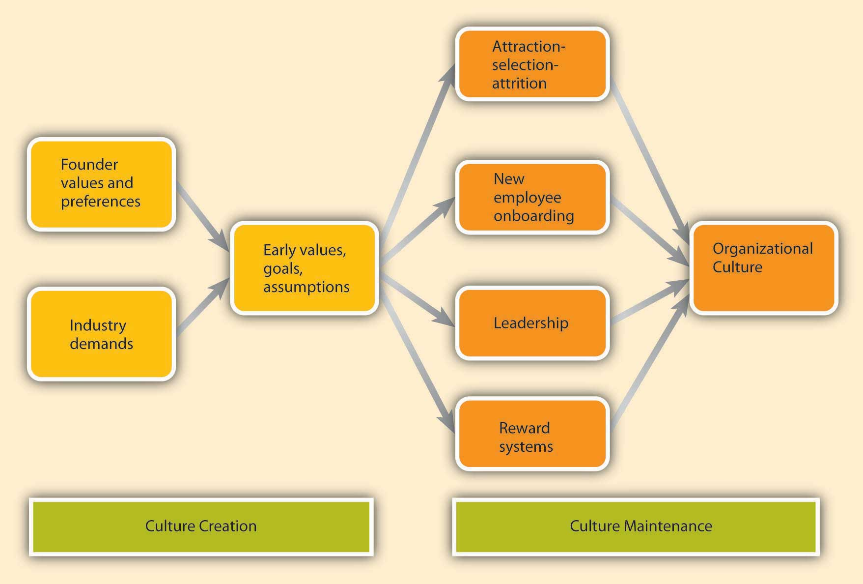
Culture Creation and Maintenance
Founder values become part of the corporate culture to the degree they help the company be successful. For example, the social activism of Ben & Jerry’s was instilled in the company because founders strongly believed in these issues. However, these values probably would not be surviving 3 decades later if they had not helped the company in its initial stages. In the case of Ben & Jerry’s, these charitable values helped distinguish their brand from larger corporate brands and attracted a loyal customer base. Thus, by providing a competitive advantage, these values were retained as part of the corporate culture and were taught to new members as the right way to do business. Similarly, the early success of Microsoft may be attributed to its relatively aggressive corporate culture, which provided a source of competitive advantage.

Industry Demands
While founders undoubtedly exert a powerful influence over corporate cultures, the industry characteristics also play a role. Industry characteristics and demands act as a force to create similarities among organizational cultures. For example, despite some differences, many companies in the insurance and banking industries are stable and rule oriented, many companies in the high-tech industry have innovative cultures, and companies in the nonprofit industry tend to be people oriented. If the industry is one with a large number of regulatory requirements—for example, banking, health care, and nuclear power plant industries—then we might expect the presence of a large number of rules and regulations, a bureaucratic company structure, and a stable culture. Similarly, the high-tech industry requires agility, taking quick action, and low concern for rules and authority, which may create a relatively more innovative culture (Chatman, & Jehn, 1994; Gordon, 1991). The industry influence over culture is also important to know, because this shows that it may not be possible to imitate the culture of a company in a different industry, even though it may seem admirable to outsiders.

How Are Cultures Maintained?
As a company matures, its cultural values are refined and strengthened. The early values of a company’s culture exert influence over its future values. It is possible to think of organizational culture as an organism that protects itself from external forces. Organizational culture determines what types of people are hired by an organization and what types are left out. Moreover, once new employees are hired, the company assimilates new employees and teaches them the way things are done in the organization. We call these processes attraction-selection-attrition and onboarding processes. We will also examine the role of leaders and reward systems in shaping and maintaining an organization’s culture. It is important to remember two points: The process of culture creation is in fact more complex and less clean than the name implies. Additionally, the influence of each factor on culture creation is reciprocal. For example, just as leaders may influence what type of values the company has, the culture may also determine what types of behaviors leaders demonstrate.

Attraction-Selection-Attrition (ASA)
Organizational culture is maintained through a process known as attraction-selection-attrition. First, employees are attracted to organizations where they will fit in. In other words, different job applicants will find different cultures to be attractive. Someone who has a competitive nature may feel comfortable and prefer to work in a company where interpersonal competition is the norm. Others may prefer to work in a team-oriented workplace. Research shows that employees with different personality traits find different cultures attractive. For example, out of the Big Five personality traits, employees who demonstrate neurotic personalities were less likely to be attracted to innovative cultures, whereas those who had openness to experience were more likely to be attracted to innovative cultures (Judge & Cable, 1997). As a result, individuals will self-select the companies they work for and may stay away from companies that have core values that are radically different from their own.
Of course this process is imperfect, and value similarity is only one reason a candidate might be attracted to a company. There may be other, more powerful attractions such as good benefits. For example, candidates who are potential misfits may still be attracted to Google because of the cool perks associated with being a Google employee. At this point in the process, the second component of the ASA framework prevents them from getting in: selection. Just as candidates are looking for places where they will fit in, companies are also looking for people who will fit into their current corporate culture. Many companies are hiring people for fit with their culture, as opposed to fit with a certain job. For example, Southwest Airlines prides itself for hiring employees based on personality and attitude rather than specific job-related skills, which are learned after being hired. This is important for job applicants to know, because in addition to highlighting your job-relevant skills, you will need to discuss why your personality and values match those of the company. Companies use different techniques to weed out candidates who do not fit with corporate values. For example, Google relies on multiple interviews with future peers. By introducing the candidate to several future coworkers and learning what these coworkers think of the candidate, it becomes easier to assess the level of fit. The Container Store Inc. ensures culture fit by hiring among their customers (Arnodl, 2007). This way, they can make sure that job candidates are already interested in organizing their lives and understand the company’s commitment to helping customers organize theirs. Companies may also use employee referrals in their recruitment process. By using their current employees as a source of future employees, companies may make sure that the newly hired employees go through a screening process to avoid potential person-culture mismatch.
Even after a company selects people for person-organization fit, there may be new employees who do not fit in. Some candidates may be skillful in impressing recruiters and signal high levels of culture fit even though they do not necessarily share the company’s values. Moreover, recruiters may suffer from perceptual biases and hire some candidates thinking that they fit with the culture even though the actual fit is low. In any event, the organization is going to eventually eliminate candidates who do not fit in through attrition. Attrition refers to the natural process in which the candidates who do not fit in will leave the company. Research indicates that person-organization misfit is one of the important reasons for employee turnover (Kristof-Brown, Zimmerman, & Johnson, 2005; O'Reilly, Chatman, & Caldwell, 1991).
As a result of the ASA process, the company attracts, selects, and retains people who share its core values. On the other hand, those people who are different in core values will be excluded from the organization either during the hiring process or later on through naturally occurring turnover. Thus, organizational culture will act as a self-defending organism where intrusive elements are kept out. Supporting the existence of such self-protective mechanisms, research shows that organizations demonstrate a certain level of homogeneity regarding personalities and values of organizational members (Giberson, Resick, & Dickson, 2005).

New Employee Onboarding
Another way in which an organization’s values, norms, and behavioral patterns are transmitted to employees is through onboarding (also referred to as the organizational socialization process). Onboarding refers to the process through which new employees learn the attitudes, knowledge, skills, and behaviors required to function effectively within an organization. If an organization can successfully socialize new employees into becoming organizational insiders, new employees feel confident regarding their ability to perform, sense that they will feel accepted by their peers, and understand and share the assumptions, norms, and values that are part of the organization’s culture. This understanding and confidence in turn translate into more effective new employees who perform better and have higher job satisfaction, stronger organizational commitment, and longer tenure within the company (Bauer et al., 2007).
There are many factors that play a role in the successful adjustment of new employees. New employees can engage in several activities to help increase their own chances of success at a new organization. Organizations also engage in different activities, such as implementing orientation programs or matching new employees with mentors, which may facilitate onboarding.

What Can Employees Do During Onboarding?
New employees who are proactive, seek feedback, and build strong relationships tend to be more successful than those who do not (Bauer & Green, 1998; Kammeyer-Mueller & Wanberg, 2003; Wanberg & Kammeyer-Mueller, 2000). For example, feedback seeking helps new employees. Especially on a first job, a new employee can make mistakes or gaffes and may find it hard to understand and interpret the ambiguous reactions of coworkers. New hires may not know whether they are performing up to standards, whether it was a good idea to mention a company mistake in front of a client, or why other employees are asking if they were sick over the weekend because of not responding to work-related e-mails. By actively seeking feedback, new employees may find out sooner rather than later any behaviors that need to be changed and gain a better understanding of whether their behavior fits with the company culture and expectations. Several studies show the benefits of feedback seeking for new employee adjustment.
Relationship building, or networking, is another important behavior new employees may demonstrate. Particularly when a company does not have a systematic approach to onboarding, it becomes more important for new employees to facilitate their own onboarding by actively building relationships. According to one estimate, 35 percent of managers who start a new job fail in the new job and either voluntarily leave or are fired within 1.5 years. Of these, over 60 percent report not being able to form effective relationships with colleagues as the primary reason for their failure (Fisher, 2005). New employees may take an active role in building relations by seeking opportunities to have a conversation with their new colleagues, arranging lunches or coffee with them, participating in company functions, and making the effort to build a relationship with their new supervisor (Kim, Cable, & Kim, 2005).

What Can Organizations Do During Onboarding?
Many organizations, including Microsoft, Kellogg Company, and Bank of America, take a more structured and systematic approach to new employee onboarding, while others follow a “sink or swim” approach in which new employees struggle to figure out what is expected of them and what the norms are.
A formal orientation program indoctrinates new employees to the company culture, as well as introduces them to their new jobs and colleagues. An orientation program is important, because it has a role in making new employees feel welcome in addition to imparting information that may help new employees be successful on their new jobs. Many large organizations have formal orientation programs consisting of lectures, videotapes, and written material, while some may follow more unusual approaches. According to one estimate, most orientations last anywhere from one to five days, and some companies are currently switching to a computer-based orientation. Ritz-Carlton, the company ranked number 1 in Training magazine’s 2007 top 125 list, uses a very systematic approach to employee orientation and views orientation as the key to retention. In the two-day classroom orientation, employees spend time with management, dine in the hotel’s finest restaurant, and witness the attention to customer service detail firsthand. For example, they receive hand-written welcome notes and their favorite snacks during the break. During these two days, they are introduced to the company’s intensive service standards, team orientation, and its own language. Later, on their 21st day, they are tested on the company’s service standards and are certified (Durett, 2006; Elswick, 2000; "The Ritz-Carlton," 2001).
Research shows that formal orientation programs are helpful in teaching employees about the goals and history of the company, as well as communicating the power structure. Moreover, these programs may also help with a new employee’s integration into the team. However, these benefits may not be realized to the same extent in computer-based orientations. In fact, compared to those taking part in a regular, face-to-face orientation, individuals undergoing a computer-based orientation were shown to have lower understanding of their job and the company, indicating that different formats of orientations may not substitute for each other (Klein & Weaver, 2000; Moscato, 2005; Wesson & Gogus, 2005).

What Can Organizational Insiders Do During Onboarding?
One of the most important ways in which organizations can help new employees adjust to a company and a new job is through organizational insiders—namely supervisors, coworkers, and mentors. Research shows that leaders have a key influence over onboarding, and the information and support leaders provide determine how quickly employees learn about the company politics and culture. Coworker influence determines the degree to which employees adjust to their teams. Mentors can be crucial to helping new employees adjust by teaching them the ins and outs of their jobs and how the company really operates. A mentor is a trusted person who provides an employee with advice and support regarding career-related matters. Although a mentor can be any employee or manager who has insights that are valuable to the new employee, mentors tend to be relatively more experienced than their protégés. Mentoring can occur naturally between two interested individuals, or organizations can facilitate this process by having formal mentoring programs. These programs may successfully bring together mentors and protégés who would not come together otherwise. Research indicates that the existence of these programs does not guarantee their success, and there are certain program characteristics that may make these programs more effective. For example, when mentors and protégés feel that they had input in the mentor-protégé matching process, they tend to be more satisfied with the arrangement. Moreover, when mentors receive training beforehand, the outcomes of the program tend to be more positive (Allen, Eby, & Lentz, 2006). Because mentors may help new employees interpret and understand the company’s culture, organizations may benefit from selecting mentors who personify the company’s values. Thus, organizations may need to design these programs carefully to increase their chance of success.

Leadership
Leaders are instrumental in creating and changing an organization’s culture. There is a direct correspondence between a leader’s style and an organization’s culture. For example, when leaders motivate employees through inspiration, corporate culture tends to be more supportive and people oriented. When leaders motivate by making rewards contingent on performance, the corporate culture tends to be more performance oriented and competitive (Sarros, Gray, & Densten, 2002).
Part of the leader’s influence over culture is through role modeling. Many studies have suggested that leader behavior, the consistency between organizational policy and leader actions, and leader role modeling determine the degree to which the organization’s culture emphasizes ethics (Driscoll & McKee). The leader’s own behaviors will signal to employees what is acceptable behavior and what is unacceptable. In an organization in which high-level managers make the effort to involve others in decision making and seek opinions of others, a team-oriented culture is more likely to evolve. By acting as role models, leaders send signals to the organization about the norms and values that are expected to guide the actions of organizational members.
Leaders also shape culture by their reactions to the actions of others around them. For example, do they praise a job well done, or do they praise a favored employee regardless of what was accomplished? How do they react when someone admits to making an honest mistake? What are their priorities? In meetings, what types of questions do they ask? Do they want to know what caused accidents so that they can be prevented, or do they seem more concerned about how much money was lost as a result of an accident? Do they seem outraged when an employee is disrespectful to a coworker, or does their reaction depend on whether they like the harasser? Through their day-to-day actions, leaders shape and maintain an organization’s culture.

Reward Systems
Finally, the company culture is shaped by the type of reward systems used in the organization, and the kinds of behaviors and outcomes it chooses to reward and punish. One relevant element of the reward system is whether the organization rewards behaviors or results. Some companies have reward systems that emphasize intangible elements of performance as well as more easily observable metrics. In these companies, supervisors and peers may evaluate an employee’s performance by assessing the person’s behaviors as well as the results. In such companies, we may expect a culture that is relatively people or team oriented, and employees act as part of a family (Kerr & Slocum, 2005). On the other hand, in companies that purely reward goal achievement, there is a focus on measuring only the results without much regard to the process. In these companies, we might observe outcome-oriented and competitive cultures. Another categorization of reward systems might be whether the organization uses rankings or ratings. In a company where the reward system pits members against one another, where employees are ranked against each other and the lower performers receive long-term or short-term punishments, it would be hard to develop a culture of people orientation and may lead to a competitive culture. On the other hand, evaluation systems that reward employee behavior by comparing them to absolute standards as opposed to comparing employees to each other may pave the way to a team-oriented culture. Whether the organization rewards performance or seniority would also make a difference in culture. When promotions are based on seniority, it would be difficult to establish a culture of outcome orientation. Finally, the types of behaviors that are rewarded or ignored set the tone for the culture. Service-oriented cultures reward, recognize, and publicize exceptional service on the part of their employees. In safety cultures, safety metrics are emphasized and the organization is proud of its low accident ratings. What behaviors are rewarded, which ones are punished, and which are ignored will determine how a company’s culture evolves.

Visual Elements of Organizational Culture
How do you find out about a company’s culture? We emphasized earlier that culture influences the way members of the organization think, behave, and interact with one another. Thus, one way of finding out about a company’s culture is by observing employees or interviewing them. At the same time, culture manifests itself in some visible aspects of the organization’s environment. In this section, we discuss five ways in which culture shows itself to observers and employees.

Mission Statement
A mission statement is a statement of purpose, describing who the company is and what it does. Many companies have mission statements, but they do not always reflect the company’s values and its purpose. An effective mission statement is well known by employees, is transmitted to all employees starting from their first day at work, and influences employee behavior.
Not all mission statements are effective, because some are written by public relations specialists and can be found in a company’s Web site, but it does not affect how employees act or behave. In fact, some mission statements reflect who the company wants to be as opposed to who they actually are. If the mission statement does not affect employee behavior on a day-to-day basis, it has little usefulness as a tool for understanding the company’s culture. An oft-cited example of a mission statement that had little impact on how a company operates belongs to Enron. Their missions and values statement began, “As a partner in the communities in which we operate, Enron believes it has a responsibility to conduct itself according to certain basic principles.” Their values statement included such ironic declarations as “We do not tolerate abusive or disrespectful treatment. Ruthlessness, callousness and arrogance don’t belong here” (Kunen, 2002).
A mission statement that is taken seriously and widely communicated may provide insights into the corporate culture. For example, the Mayo Clinic’s mission statement is “The needs of the patient come first.” This mission statement evolved from the founders who are quoted as saying, “The best interest of the patient is the only interest to be considered.” Mayo Clinics have a corporate culture that puts patients first. For example, no incentives are given to physicians based on the number of patients they see. Because doctors are salaried, they have no interest in retaining a patient for themselves and they refer the patient to other doctors when needed (Jarnagin & Slocum, 2007). Wal-Mart Stores Inc. may be another example of a company who lives its mission statement, and therefore its mission statement may give hints about its culture: “Saving people money so they can live better.” In fact, their culture emphasizes thrift and cost control in everything they do. For example, even though most CEOs of large companies in the United States have lavish salaries and showy offices, Wal-Mart’s CEO Michael Duke and other high-level corporate officers work out of modest offices in the company’s headquarters.

Rituals
Rituals refer to repetitive activities within an organization that have symbolic meaning (Anand, 2005). Usually rituals have their roots in the history of a company’s culture. They create camaraderie and a sense of belonging among employees. They also serve to teach employees corporate values and create identification with the organization. For example, at the cosmetics firm Mary Kay Inc., employees attend award ceremonies recognizing their top salespeople with an award of a new car—traditionally a pink Cadillac. These ceremonies are conducted in large auditoriums where participants wear elaborate evening gowns and sing company songs that create emotional excitement. During this ritual, employees feel a connection to the company culture and its values, such as self-determination, will power, and enthusiasm (Jarnagin & Slocum, 2007). Another example of rituals is the Saturday morning meetings of Wal-Mart. This ritual was first created by the company founder Sam Walton, who used these meetings to discuss which products and practices were doing well and which required adjustment. He was able to use this information to make changes in Wal-Mart’s stores before the start of the week, which gave him a competitive advantage over rival stores who would make their adjustments based on weekly sales figures during the middle of the following week. Today, hundreds of Wal-Mart associates attend the Saturday morning meetings in the Bentonville, Arkansas, headquarters. The meetings, which run from 7:00 to 9:30 a.m., start and end with the Wal-Mart cheer; the agenda includes a discussion of weekly sales figures and merchandising tactics. As a ritual, the meetings help maintain a small-company atmosphere, ensure employee involvement and accountability, communicate a performance orientation, and demonstrate taking quick action (Schlender, 2005; "Wal around the world," 2001).

Rules and Policies
Another way in which an observer may find out about a company’s culture is to examine its rules and policies. Companies create rules to determine acceptable and unacceptable behavior, and thus the rules that exist in a company will signal the type of values it has. Policies about issues such as decision making, human resources, and employee privacy reveal what the company values and emphasizes. For example, a company that has a policy such as “all pricing decisions of merchandise will be made at corporate headquarters” is likely to have a centralized culture that is hierarchical, as opposed to decentralized and empowering. Similarly, a company that extends benefits to both part-time and full-time employees, as well as to spouses and domestic partners, signals to employees and observers that it cares about its employees and shows concern for their well-being. By offering employees flexible work hours, sabbaticals, and telecommuting opportunities, a company may communicate its emphasis on work-life balance. The presence or absence of policies on sensitive issues such as English-only rules, bullying or unfair treatment of others, workplace surveillance, open-door policies, sexual harassment, workplace romances, and corporate social responsibility all provide pieces of the puzzle that make up a company’s culture.

Physical Layout
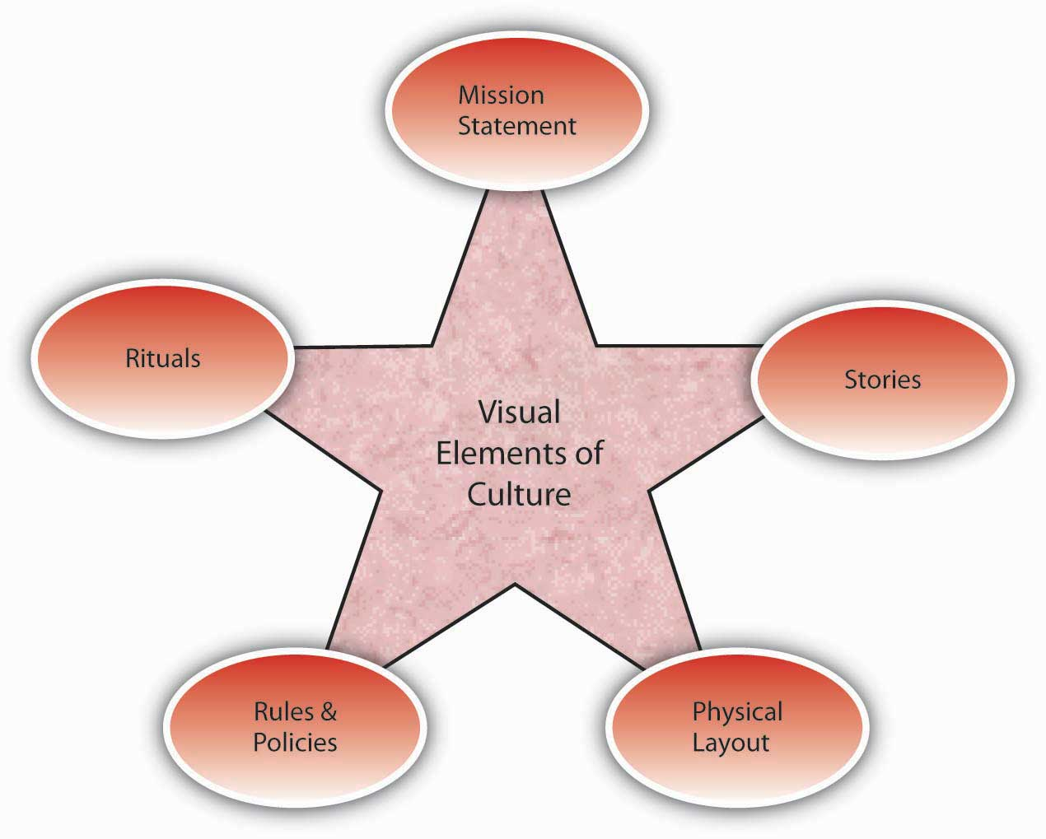
Culture Creation and Maintenance
A company’s building, including the layout of employee offices and other work spaces, communicates important messages about a company’s culture. The building architecture may indicate the core values of an organization’s culture. For example, visitors walking into the Nike Inc. campus in Beaverton, Oregon, can witness firsthand some of the distinguishing characteristics of the company’s culture. The campus is set on 74 acres and boasts an artificial lake, walking trails, soccer fields, and cutting-edge fitness centers. The campus functions as a symbol of Nike’s values such as energy, physical fitness, an emphasis on quality, and a competitive orientation. In addition, at fitness centers on the Nike headquarters, only those wearing Nike shoes and apparel are allowed in. This sends a strong signal that loyalty is expected. The company’s devotion to athletes and their winning spirits is manifested in campus buildings named after famous athletes, photos of athletes hanging on the walls, and honorary statues dotting the campus. (Capowski, 1993; Collins & Porras, 1996; Labich & Carvell, 1995; Mitchell, 2002). A very different tone awaits visitors to Wal-Mart headquarters, where managers have gray and windowless offices (Berner, 2007). By putting its managers in small offices and avoiding outward signs of flashiness, Wal-Mart does a good job of highlighting its values of economy.
The layout of the office space also is a strong indicator of a company’s culture. A company that has an open layout where high-level managers interact with employees may have a culture of team orientation and egalitarianism, whereas a company where high-level managers have their own floor may indicate a higher level of hierarchy. Microsoft employees tend to have offices with walls and a door, because the culture emphasizes solitude, concentration, and privacy. In contrast, Intel Corporation is famous for its standard cubicles, which reflect its culture of equality. The same value can also be observed in its avoidance of private and reserved parking spots. The degree to which playfulness, humor, and fun is part of a company’s culture may be indicated in the office environment. For example, Jive Software boasts a colorful, modern, and comfortable office design. Their break room is equipped with a keg of beer, free snacks and sodas, an XBOX 360, and Nintendo Wii. A casual observation of their work environment sends the message that employees who work there see their work as fun.

Stories
Perhaps the most colorful and effective way in which organizations communicate their culture to new employees and organizational members is through the skillful use of stories. A story can highlight a critical event an organization faced and the collective response to it, or can emphasize a heroic effort of a single employee illustrating the company’s values. The stories usually engage employee emotions and generate employee identification with the company or the heroes of the tale. A compelling story may be a key mechanism through which managers motivate employees by giving their behavior direction and energizing them toward a certain goal (Beslin, 2007). Moreover, stories shared with new employees communicate the company’s history, its values and priorities, and serve the purpose of creating a bond between the new employee and the organization. For example, you may already be familiar with the story of how a scientist at 3M invented Post-it notes. Arthur Fry, a 3M scientist, was using slips of paper to mark the pages of hymns in his church choir, but they kept falling off. He remembered a super-weak adhesive that had been invented in 3M’s labs, and he coated the markers with this adhesive. Thus, the Post-it notes were born. However, marketing surveys for the interest in such a product were weak, and the distributors were not convinced that it had a market. Instead of giving up, Fry distributed samples of the small yellow sticky notes to secretaries throughout his company. Once they tried them, people loved them and asked for more. Word spread, and this led to the ultimate success of the product. As you can see, this story does a great job of describing the core values of a 3M employee: Being innovative by finding unexpected uses for objects, persevering, and being proactive in the face of negative feedback (Higgins & McAllester, 2002).

Key Takeaway
Organization cultures are created by a variety of factors, including founders’ values and preferences, industry demands, and early values, goals, and assumptions. Culture is maintained through attraction-selection-attrition, new employee onboarding, leadership, and organizational reward systems. Signs of a company’s culture include the organization’s mission statement, stories, physical layout, rules and policies, and rituals.

References

